New or Improved Product Video Presentation
In groups of 2 , use google to search for a list of new products created this year in 2024 or use the article on my class webpage for some top items in 2024. Pick a new or improved product for 2024 and create a promotional voice over video about the product using Canva.com. Your task is to create a still (using pictures, text, and graphics) promotional video (with your voices) about a new or improved product that is being sold in the marketplace currently. You have been hired by the producer of the product to create a video that will be posted as an ad on YouTube. Show off your product and tell your customers about it. What it is, what it does, if it is new or improved, what are the features that will make people want it. It’s that simple. Below is a list of items that must be included in the video. You must create your video in Canva, download it as an MP4, and turn it into the google classroom.
Student Names:
- Product Selected:
- Must be approved by your instructor
- Must be different than anyone else in the room (first come first serve)
- Can not be a phone of any type
- Must be done in Canva.
- Sign up for your class in Canva. A link was sent via google classroom in the stream. Once in Canva, your class hour should be listed on the left side of the screen
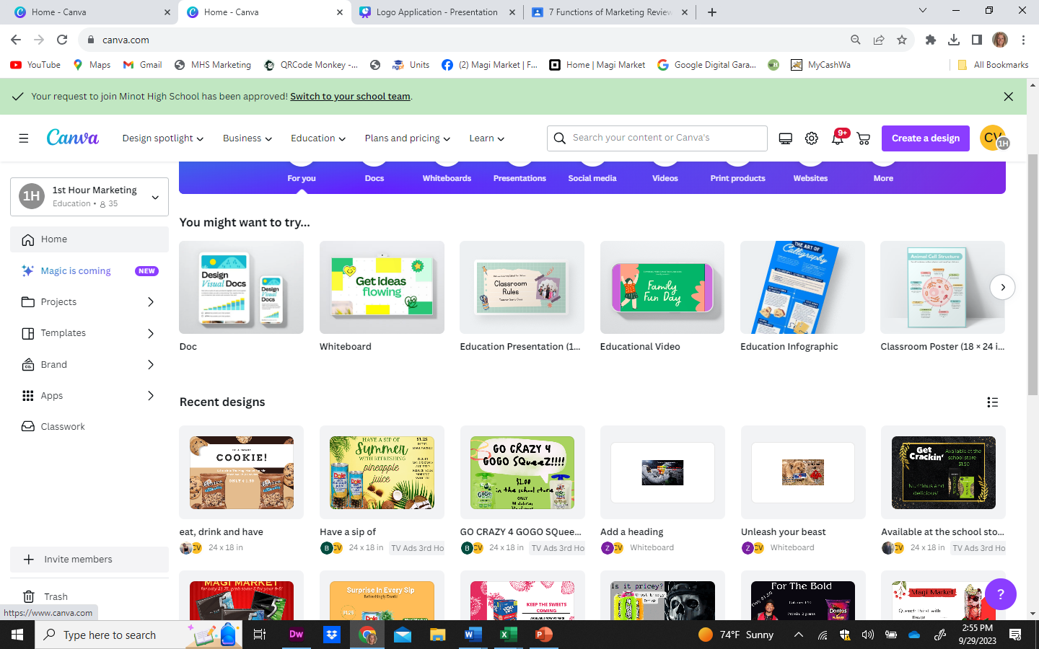
- Create a Presentation
  - Select a Presentation 16.9 layout from the many options within Canva. Find one that fits your needs. It needs to be a free version and work for creating a short video
  - Create Your presentation using the Rubric on the Back to ensure all items are included
  - Create your text, upload pictures and use the graphics within Canva
  - Add Transitions and Animations to your project as movement always adds effect to a presentation. This can be done by adding stickers under effects, or animation from the menu options.
- When complete Script what you will say for your video on page 3 of this document
- Record your voice in Canva
  - Select Present in the upper right-hand corner of Canva
  - Select Present and Record
  - Change the Camera to No Camera
  - Use the Pause and Record to record your voice. Practice this first, and use inflection in your voice when describing your product. Make sure you both take turns presenting your script.
  - Record your video using a sales pitch tone of voice to tell people about your product.
- Upload your video file direct to google classroom as an attachment. When completed, mark the assignment as Turned in.
Is your Product New or Improved?
List several of the Form Utility (features that will make people want this product)

Price of the Product:
 | Possible Points | Deducted | Total Score
Presentation points:
Answered Questions in space above: | 5
The name of the product (below the name is smaller font, put the name of all your partners so I know who to score) | 5
Include a Visual Representation of your product, pictures, video clip, graphic etc. throughout your presentation – keep the item in the mind of the viewer. | 10
Give a brief description of your product what it is and does. | 10
Features: Highlight the features (you listed above) in your video that make people want it.  - focus on and describe the features that will make people want it?  - What problem is your product solving?  - How does it enrich your customers’ lives?  - Is it inspiring a customer to do more? | 10
- A call-to-action - Where can the item be purchased – list 2 – 3 places | 10
- If Price is available, include how much it will cost at the end of your video | 5
- Have fun with this assignment. It does not have to be perfect; it just is the start of the many projects we do in class. | 0
Other Points | 0
Added animations to the presentation | 10
Selected a new or improved product that is not being presented by another group in your class. | 5
Both/All partners were in the video or spoke in the video. | 5
Used a Sales tone of voice. | 5
Creative and appropriate in the classroom. | 10
In Google Classroom.  Complete the questions in the Google Form  Download the video as an MP4  Attach and HAND in the video into Google Classroom | 10
Score | 100

Script Your video Here:

